Git Hub Task -1

- Create a GitHub account.
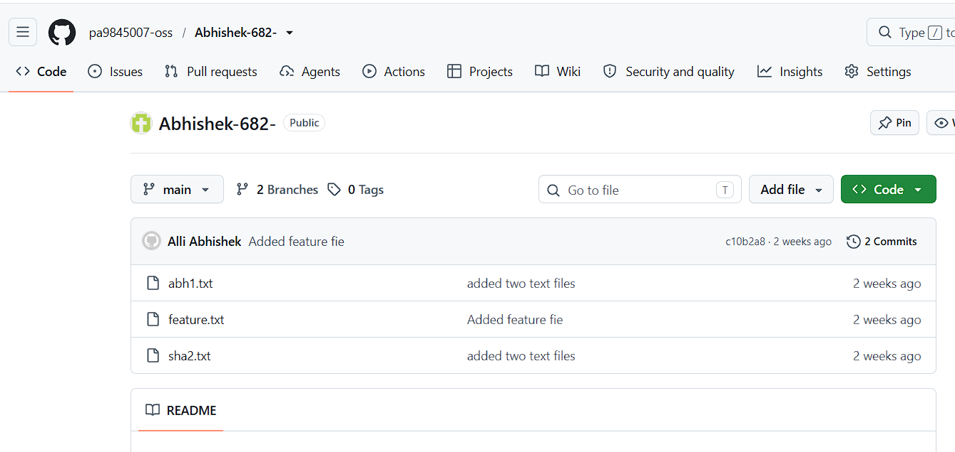

2.Set up MFA For the git hub account using a mobile app
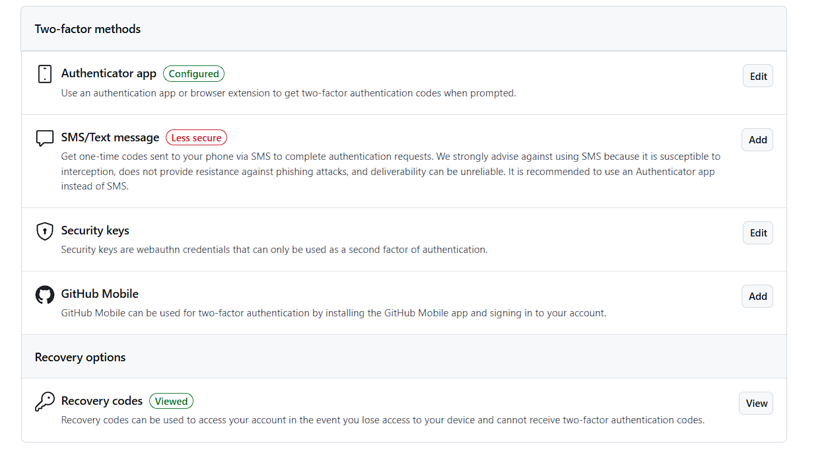
3.Execute all commands shown in the video.

1.Check the installed Git version.

2. git status →
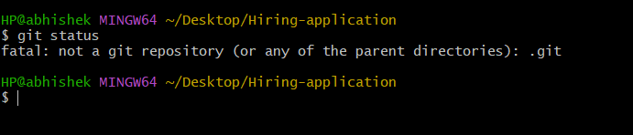
4.Initializes a Git repository in the current directory.


5. git config -l
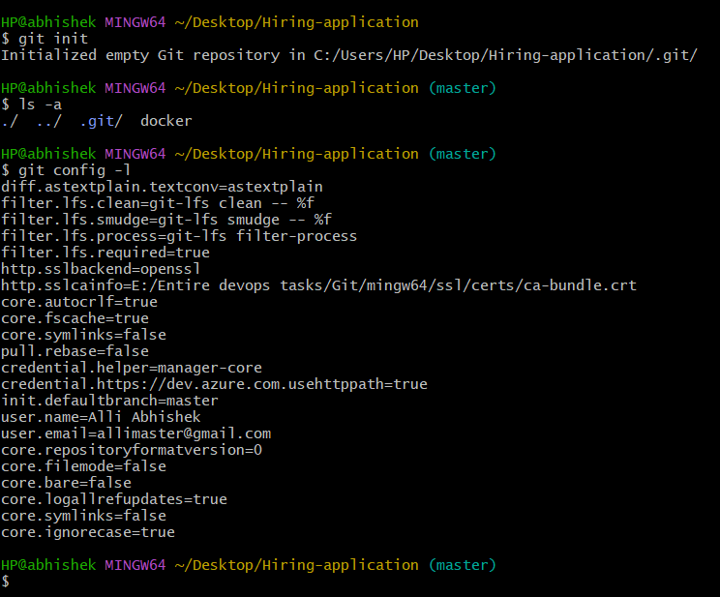

6.
8. git add
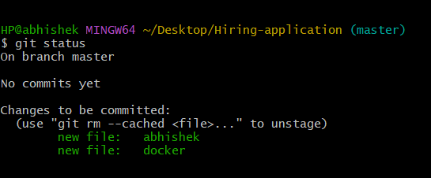
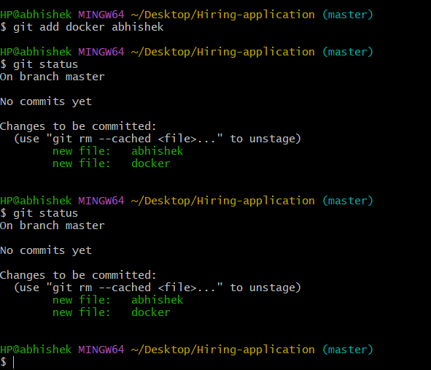
9. git reset.

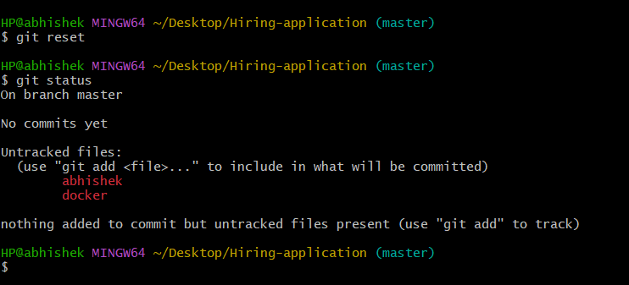

10. git commit -m “message”
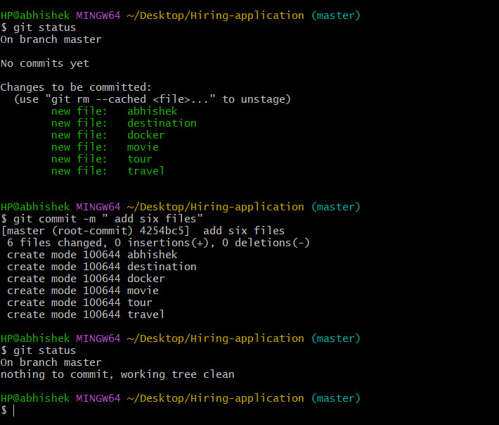

11. git log
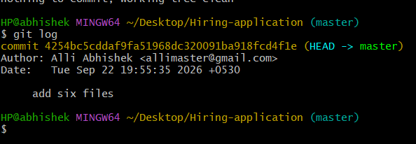
12. . git push -u origin master
13. git remote add origin <URL>
14.git remote

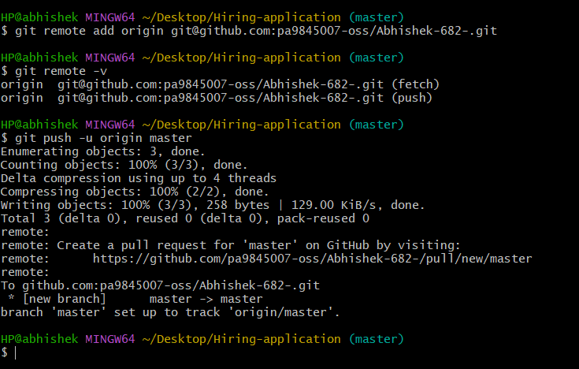

15.git pull
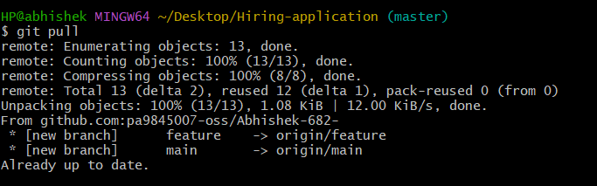
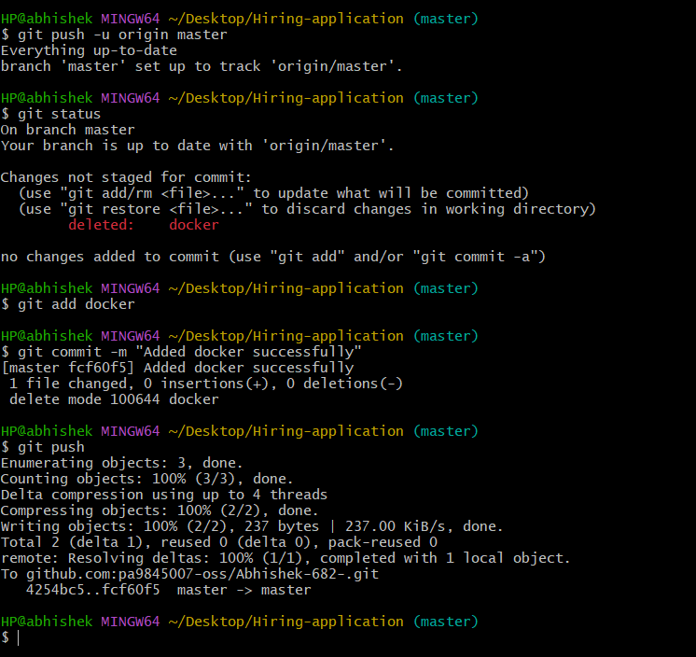

16. git clone
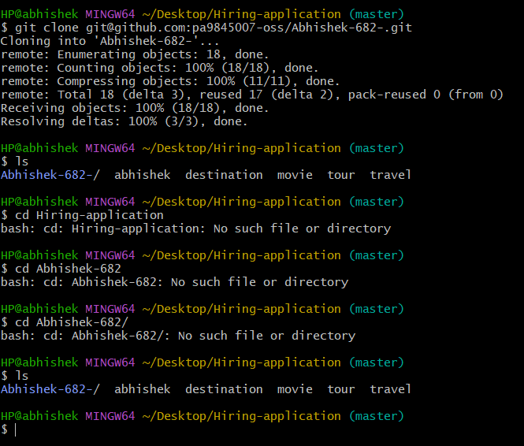
17.git revert
